第二届中国人工智能创新大赛（大学组）

人工智能应用创意赛

作品说明书

作品名称： Poultry diseases identification based on EasyDL

参赛单位： 河南理工大学

团队队员： Nishith Ranjan Biswas, Md Shahriar Haque,Ammara Gill

队长电话： +8615538916514

指导老师： 谷亚楠

联系电话： +8618300626153

### Poultry diseases Identification based on EasyDL

1. **Topic selection description (选题说明)**
   1. **design background (设计背景)**

##### Chicken diseases detection is the most emergent research topic in the poultry industry. The poultry sector in China is economically significant because it is now the world’s leading poultry production country. It is associated with public health risks arising from various diseases, and it has suffered extensive economic losses. Production is greatly affected by devastating diseases.

In recent years, with the advancement of machine learning technology and the continuous improvement of computing power, artificial intelligence technology, especially deep learning technology, has been developing rapidly and is widely used in computer vision, speech recognition, natural language processing and several fields. Agricultural researchers have also begun to use gradually deep learning technology to carry out research. M Sadeghi (2015) proposed a method for Detection and Classification of Chickens Infected by diseases based on their Vocalization. The application of intelligent algorithms such as machine learning can establish a mathematical model for identifying a chicken disease by doing an experiment of 30 days. Classification accuracy was 66.6 and 100%; In addition, the way of thinking of big data (Lake et al., 2015) has also been increasingly applied in the field of earth sciences, profoundly changing the research methods of scientists (Zhang Qi and Zhou Yongzhang, 2017; Zhou Yongzhang, etc., 2017). Xiaolin Zhuang et al. (2019) published a research paper on the Detection of sick broilers by digital image processing and deep learning. In this paper, a model structure was proposed to identify sick chickens within a flock by using digital image processing and deep learning. Overall, this project is based on EasyDL Detection of disease from images of feces. The team used EasyDL's customized training service platform. The results indicate that sick chickens within a flock can be successfully detected automatically and the method has the potential to facilitate efficient flock management.

Domestically, we have collected 992 feces images and used EasyDL to extract and compress feature information. Three kinds of common diseases were detected and classified and the accuracy of the training set reached 97.0%, the total number of samples marked as this type reached 96.5%. The average recall rate for each category reached 93.5%. This project requires a large number of data sets to ensure the accuracy and validity of the results. We have collected a large number of feces images from many sources. And because deep learning will generate a large amount of parameter data during model training, especially for image data that requires powerful hardware function support, we use the EasyDL customized training service platform for model training. This method does not require manually extracting the image features of feces, eliminates the influence of subjective factors; it can be used for actual needs, reduces the cost of identifying chicken diseases, and is of great significance to resource exploration, poultry, agricultural protection, and economy exploration in Bangladesh and all over the world.

* 1. **Aim of design(设计目的)**

Detecting chicken disease is one of the emergent parts of poultry research. This design aims to determine the prevalence and intensity of parasitic gastrointestinal infections in free-range chickens. Classical machine learning techniques have already been used before studies for disease detection and classification. In this research detection of poultry, diseases are based on deep learning. The annotated dataset of poultry disease diagnostics for small to medium-scale poultry farmers consists of poultry fecal images. The accuracy of this project proves that it **might** connect with China’s “Belt and Road Initiative” (BRI) **that may be a** development strategy **concerning** building partnerships and infrastructure **to spice up** trade among regional countries. Although by the help of the “Belt and Road Initiative” (BRI) in Bangladesh village-based poultry are completely separate from commercial enterprises, it will be vital to include this sector in health services and surveillance. It will create a good impact on Bangladesh’s Poultry and how China’s investments would influence the changes in Bangladesh.

* 1. **Market research status (市场调研现状)**
     1. **Research background (调研背景)**

Poultry production in Asian countries is characterized preponderantly by backyard-type small-scale operations for a protracted time. They foster historically their native birds as scavenging systems with awfully little profit. The most rural family has some poultry and women are the risers of those Chickens. Poultry keeping is one among the foremost acceptable incomes generating activities for rural ladies. Throughout the **previous couple of** years, business farming has become **one of the foremost** profitable industries **within the Asian country.** Several farmers amendment their ancient rearing system and become fashionable business poultry rearers. A small-scale poultry rearing has become a helpful occupation for ladies and also the young generation of the country. The prevalence of diseases in a particular area depends on various factors like geo-climatic condition, management practices, immunization status, social awareness, etc. To establish a commercial poultry farm, the incidence of poultry diseases of the area should be considered for prevention and control of the diseases.

The identification of Chicken disease is a very important content in agricultural research. Many scholars have used different methods to study them.

In fact poultry industry in Bangladesh, the farmers have to face different kinds of challenges and obstacles. The chicken disease is one of them. There are a lot of diseases by which the chicken gets infected. Bangladesh's most prevalent diseases of commercial chickens at Sylhet division include infectious bursal disease (IBD), colibacillosis, Newcastle disease (ND), salmonellosis, coccidiosis, and aspergillosis. Have a certain understanding of the percentage of various chicken diseases from the figure below.

Figure 1

Only because of different kinds of disease every year the owner of the poultry farm or the farmers used to face an extensive economic loss. Countless chickens died from this disease as well as egg production also gets interrupted in the long run. In the development of the poultry industry, our team conducted extensive research on issues such as images of feces particles. The poultry industry in Bangladesh plays a vital role in the rural socio-economic system by contributing significantly to economic growth and simultaneously creating numerous employment opportunities. By Belt and Road Initiative” (BRI) it can also deal with other countries and increase their economic values.

* + 1. **Investigation and Analysis (调研分析)**

Bangladesh experiences a number of the very best deficiency disease rates within the world, The incidence of aflatoxicosis was highest (27.59%) followed by nutritional deficiency (12.40%), infectious bursal disease (11.80%), chronic respiratory disease (8.11%), Newcastle disease (7.50%) salmonellosis (5.56%) colibacillosis (4.42%), fowl cholera (3.08%) were found. 5.32% of cases remain undiagnosed due to a lack of diagnostic facilities or autolysis of the bird. In sero-evaluation, commercial and native birds were found 93-97, 80 -55, 56-12, 60-73, 67-61, and 22-3% seropositive for Newcastle disease and others. Efforts are being created to extend food security and overall health standing. The most important constraints on increasing food security is endemic diseases among stock and poultry populations. In recent years, the demand for poultry merchandise in Bangladesh has full-grown significantly; per capita consumption each year exaggerated to 8.5 weight unit poultry meat and 5.1 weight unit (104 pieces) eggs in 2019. However, to fulfill the growing domestic demand, the productivity of the Bangladesh poultry sector must increase considerably.

Table 1: Contribution of livestock and poultry in national economy of Bangladesh

|  |  |
| --- | --- |
| **Particulars** | **Contribution** |
| Contribution in livestock in Gross Domestic Product (GDP) | 2.50% |
| GDP growth rate of livestock | 2.83% |
| GDP volume in million (bdt) | 13,2580 |
| Share of livestock in agriculture GDP | 14.08% |
| Foreign exchange earnings (from hides and skin) | 4.31% |
| Nutrition (combined with fisheries sector) | 80% |
| Employment (directly) | 20% |
| Employment (partly) | 50% |

Besides poultry is one of the most consumed meat after pork worldwide. Among all the meats about 35% meats come from the poultry industry.

Figure 2

* + 1. **Survey results (调研结果)**

After extensive market research, the team analyzed the results of the survey and concluded that investing in the poultry industry could be a key field of the BRI project of China. Especially in Bangladesh, Pakistan, Saudi Arabia, Philippines, Indonesia, and Laos. It will establish and strengthen partnerships among the countries along the Belt and Road, set up all-dimensional, multi-tiered, and composite connectivity networks and it realize diversified, independent, balanced and sustainable development in these countries.

In Bangladesh, It is found that the prevalence of poultry diseases were significantly highest in the summer season (39.85 %) followed by winter (32.80%) and the rainy season (27.35%). Although disease prevalence in winter is always comparatively lower than in another season, sometimes this season also shows the highest diseases prevalence.

From a market perspective, as deep learning becomes more and more popular in life and work, more people understand that the future development of intelligence is an unstoppable trend. There is an extremely large gap between the deep learning field and the poultry field in reality. Farmers still are not much aware of using Artificial intelligence in the Poultry field. Compared to other markets in Asia-Pacific, the poultry sector in Bangladesh is relatively underdeveloped in virtually all steps of the value chain, though what stands out is the absence of a professional downstream segment. Using AI in this field is almost a new feature in Bangladesh. The gap **within the** market has established **the event** of intelligent **unwellness** detection and **conjointly**shows that the existence of this project is **very massive.** If **we will** use the deep learning **technique during this huge** agricultural field **it'll**bring a revolutionary **amendment.** I**t'll facilitate the state** in nutrition **furthermore**as **within the** economy. I**t'll**not **solely cut backhands,** material, and **money** resources **however conjointly** improve the work **potency** of farmers and **cut back** the death rate of chickens in poultry farms.

1. **The content of the work (作品内容)**

## Main content (主要内容)

## The annotated dataset of poultry disease diagnostics for small to medium-scale poultry consists of poultry fecal images. The poultry fecal images were taken in Arusha and Kilimanjaro regions in Tanzania between September 2020 and February 2021 using the Open Data Kit (ODK) app on mobile phones. The typical normal fecal material which is the ‘healthy’ class and Coccidiosis disease, the ‘cocci’ class were taken from poultry farms. The chickens were inoculated for Salmonella disease and fecal images were taken from the diseased chickens for the ‘Salmo’ class after one week. The chickens were also inoculated for Newcastle disease and fecal images for the 'NCD' class were taken within three days.

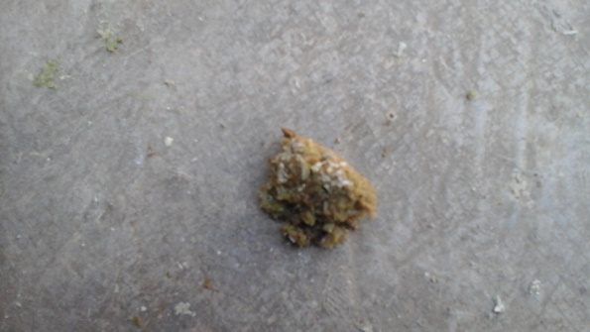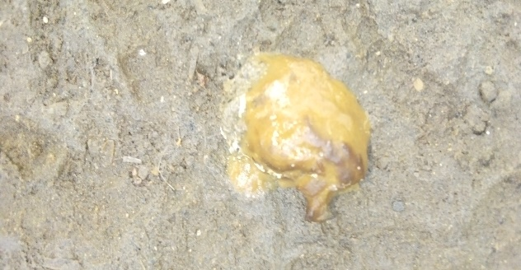The feces images of the chicken which is Healthy or Coccidiosis disease, Salmonella, and Newcastle disease infected are given in the figure below.

Coccidiosis

Healthy

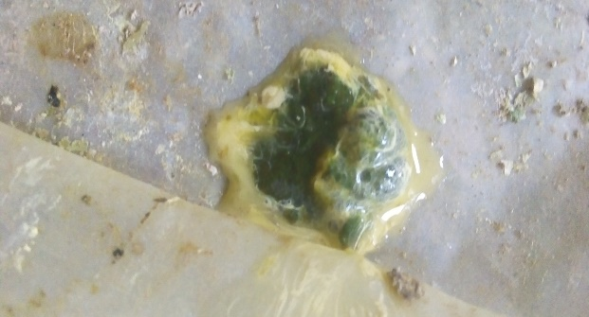

Salmonella

Newcastle

Figure 3: Feces images of different kinds of disease infected chicken

Table 2: Types and quantity of chicken feces images

|  |  |
| --- | --- |
| **Types** | **Quantity of images** |
| Coccidiosis disease | 335 |
| Salmonella disease | 303 |
| Newcastle disease | 90 |
| Healthy chicken | 264 |

* 1. **Innovation (创新点)**

The majority of poultry farms in Bangladesh utilize traditional methods of poultry farming. However, poultry diseases constrain further development and hamper the industry’s productivity. During recent years, about 30% of the poultry flock in Bangladesh died annually due to several disease outbreaks. The emerging diseases and unknown causes result in farmers’ losses. Many of these diseases also pose hazardous threats to human health. Every year thousands of farms are collapsing due to chicken deaths. Moreover, there is no nationwide systematic approach to collect and share data on poultry diseases (government, veterinarian, and farmer level) in Bangladesh. As almost none of the carcasses are sent for post-mortem diagnosis, Bangladeshi stakeholders are often unaware of current diseases. Early disease detection can play a vital role in the prevention of disease outbreaks. We present the chicken disease detection method using EasyDL. The creation of such image processing techniques that can assist farmers is a necessity of the modern period. These methods are valuable to reduce the losses incurred and increase productivity. The experimental findings indicate that our method works well on diseases detection in the chicken and can be used for strong diagnostics and it is clear that the diseases can be detected at an early stage before they lead to deaths of the chicken. The future depends on technology. Bangladesh is committed to walking through the path. Using the tagline “AI for Innovative Bangladesh” we can say the early disease detection method using EasyDL will be a new beginning in the poultry sector in our country which will go one step further in the development of the poultry industry.

**2.3Technical route (技术路线)**

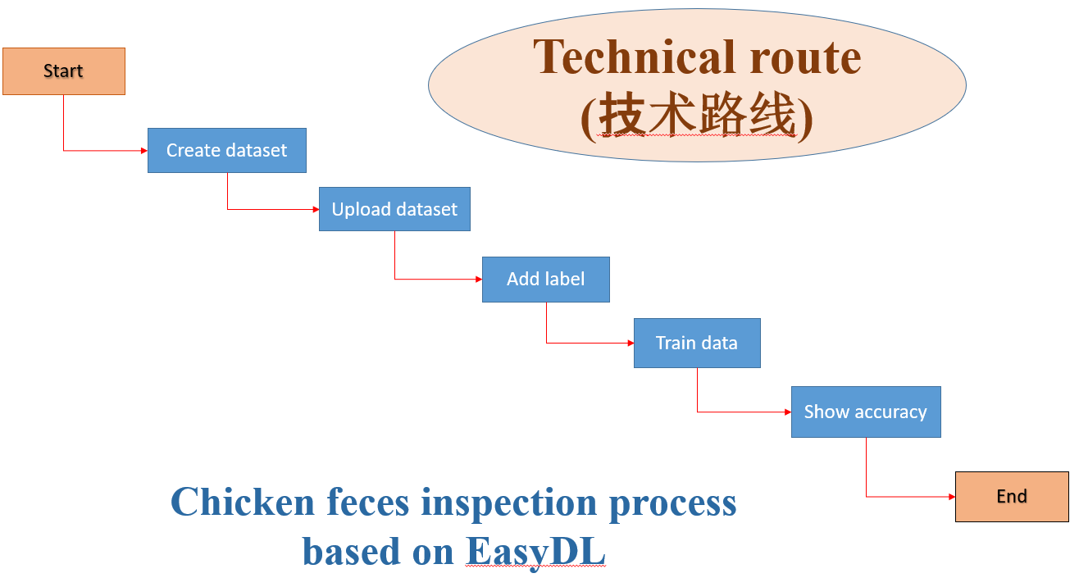

Figure 4: Chicken feces inspection process based on EasyDL

Deep learning needs to use a large number of sample data to extract features for classification. However, the actual amount of image data is relatively large and the training parameters are also large. So good hardware support is required. Therefore, our team adopted the EasyDL customized training service platform for model training to classify different types of chicken feces images. The flowchart given below in Fig 4 represents the training process of the model using the EasyDL platform.

## Specific steps (具体步骤)

**Step 1: Choose a model**

Choose the appropriate model according to the project requirements. This project wants to achieve is to classify the different types of disease- infected and healthy chicken feces.

**Step 2: Create the model**

When we classify the feces image, we need to select and build a model. We will perform a series of operations on this model, and finally, train a model with better generalization ability.

**Step 3: Uploading data.**

In this step, we need to upload the image data from the dataset. Figure 5 describes the process.

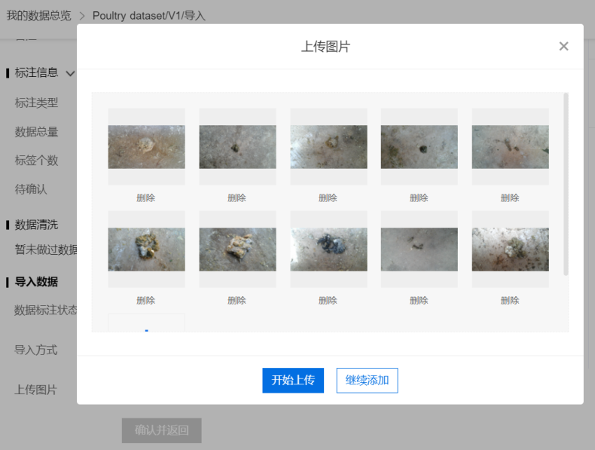

Figure 5 : Uploading image data.

Step 4: Using polygonal to select the desired area and Labeling the image data. Figure 6 shows the process.

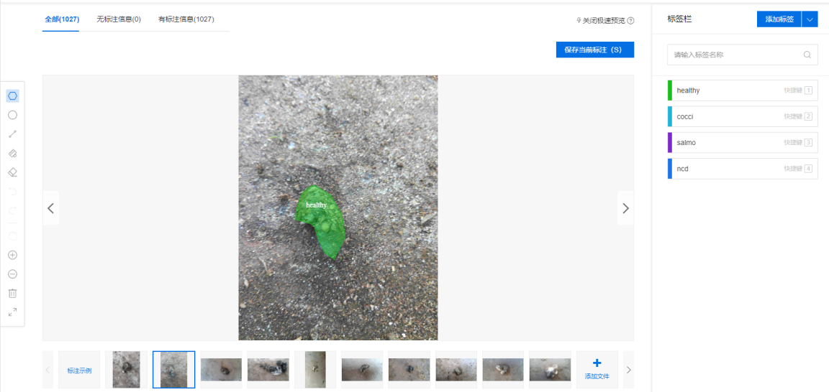

Figure 6: labeling data

Step 5: Train the data

After training, it shows the result of the model and also shows the wrong picture of the model by labeling. Figure 7 shows the result of the training model for chicken feces image classification.

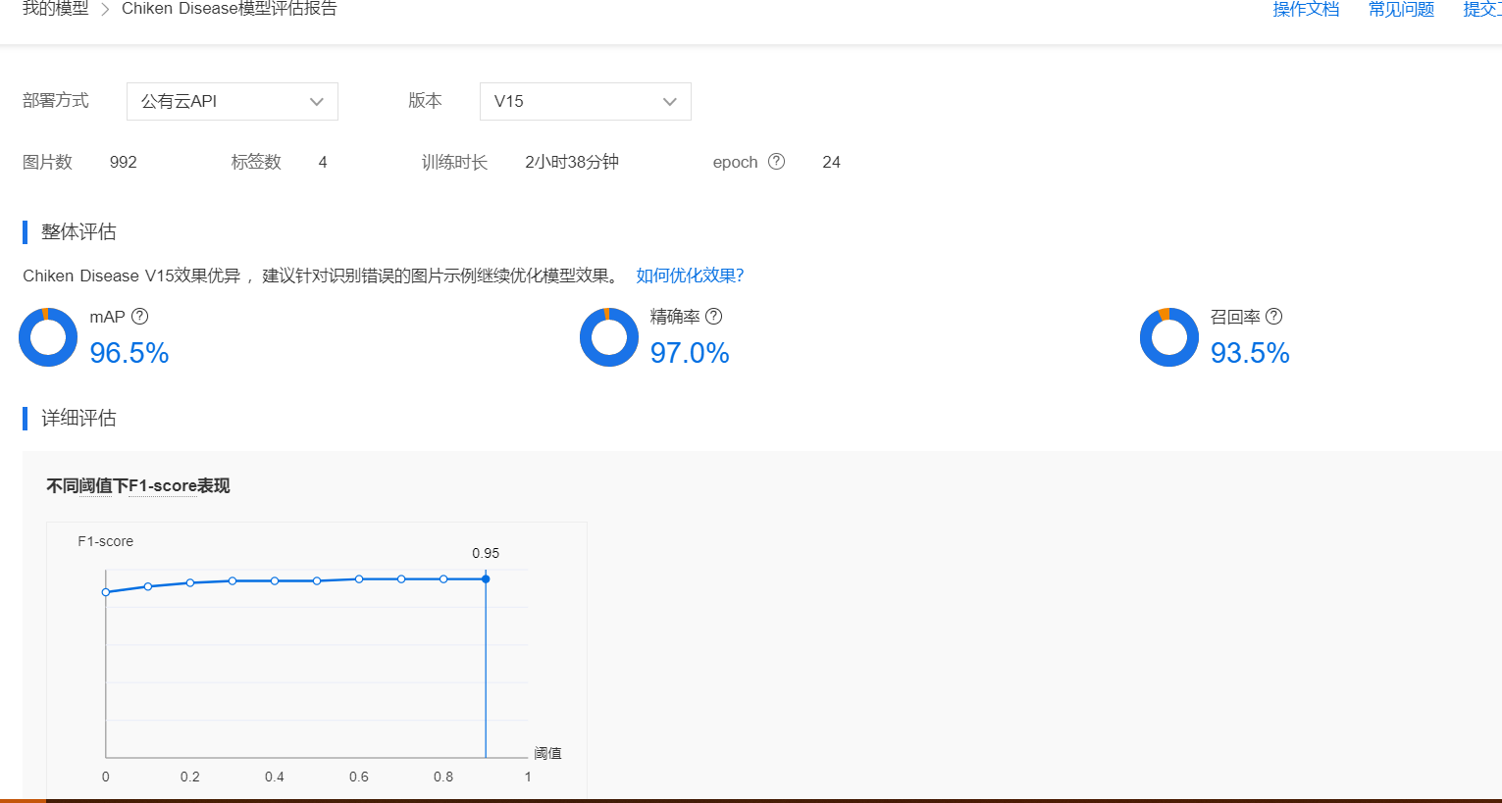

Figure 7: Result of a training model

Here,

1. **mAP:** (mean average precision) is an index that measures the effect of the algorithm in the object detection algorithm. For object detection tasks, each type of object can calculate its precision (Precision) and recall (Recall), multiple calculations/tests under different thresholds, each class can get a PR curve, the area under the curve is average.
2. **Accuracy:** After comparing the results under the highest F1-score threshold of 0.9. The accuracy is the ratio of the number of correctly predicted objects to the total number of predicted objects under this threshold.
3. **Recall rate:** After comparing the results under the highest F1-score threshold of 0.9. The recall rate is the ratio of the number of correctly predicted objects to the number of real objects under this threshold

Step 6: Publish the model—offline SDK

Step 7: Verify the model.

After the model is verified, a certain degree of accuracy can be achieved, and the model can be released if it meets the requirements for the model to go online.

After the model has been trained, use the pictures in the test set to verify the training effect

and generalization ability of the model. According to the problem, the data can be relabeled and retrained. Figure 6 shows the result after verifying the model.

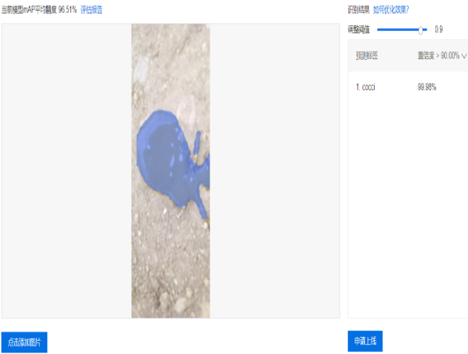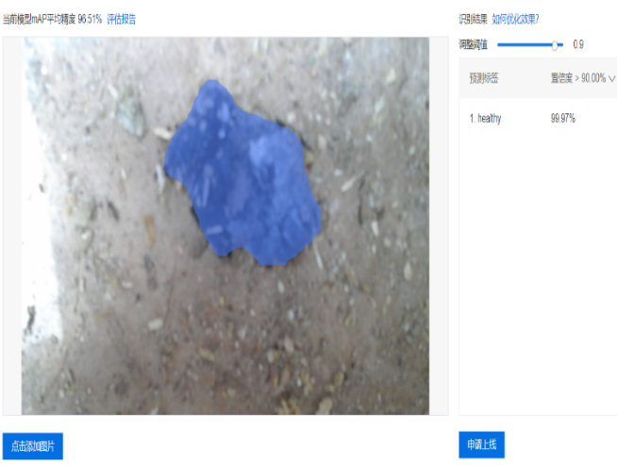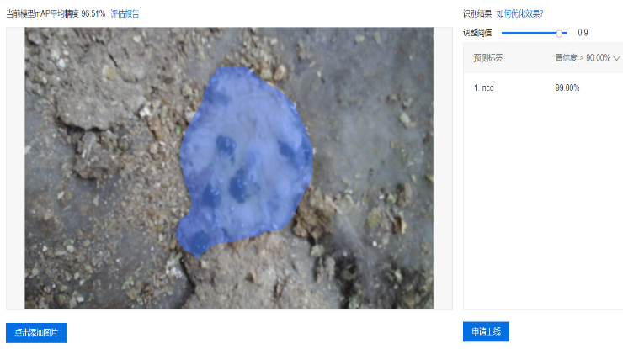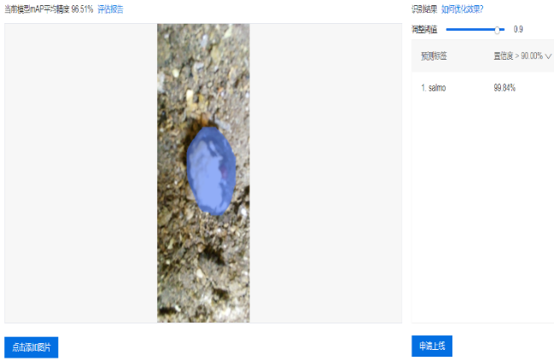

Figure 9: Testing the model

From Fig 9 we can see that the model is working very well. The model has recognized the Healthy chicken feces with the accuracy of 99.97%, Coccidiosis disease infected chicken feces with the accuracy of 99.98%, Salmonella disease infected chicken feces with the accuracy of 99.54%, and Newcastle disease infected chicken feces with the accuracy of 99.0%.

1. **Application scenarios (应用场景)**

Detecting chicken disease is one of the most basic tasks in poultry research. The traditional method of detecting disease requires many processes, which are time-consuming and laborious. The team proposed a deep learning feature extraction method based on Easy DL to detect chicken disease, manually annotate the feces images collected in actual scenes, establish a data set, and use EasyDL for training based on the constructed data set, Proofread the model and publish it for application. The project result will reduce the workload in agricultural work, improve work efficiency, and enhance the degree of intelligence.

In application, Due to the different amounts of fecal particles and the complex image structure, the effect of directly classifying them is not good. The detection results of unhealthy chicken can provide important and basic location data for the feces amount classification. After detecting the disease, feces amount in the images can be accurately classified and the accuracy rate can be calculated.